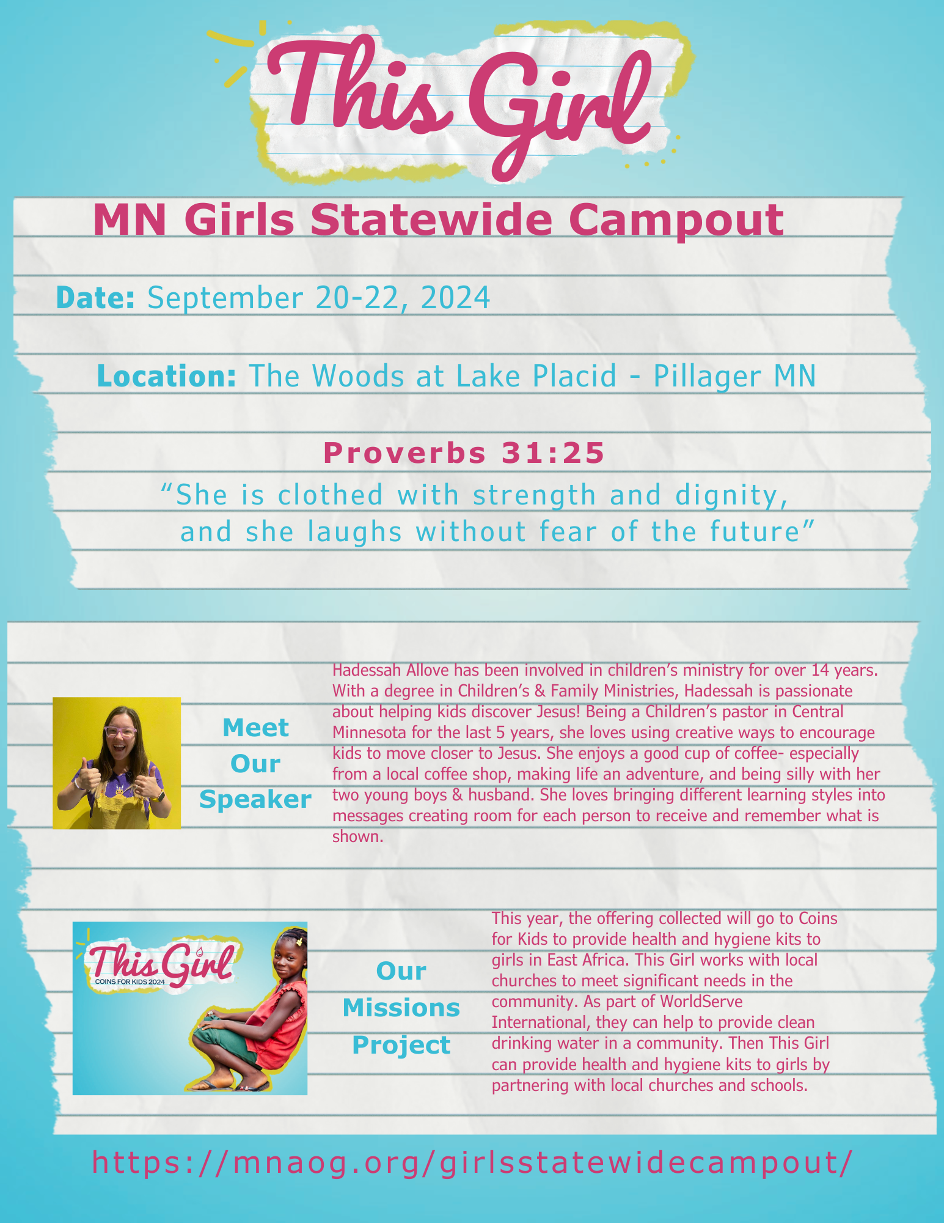


Who:

Price:

Register at:
Other Details

Things to bring:
- Spending money
  - Camp Store
  - Missions Offering
  - Girls will need money for a fast food lunch on Sunday.
- Warm sleeping bag, pillow and air mattress/pad (optional)
- Winter jacket, hat and gloves
- Rain gear/poncho
- Two complete marked sets of clothes (remember Minnesota weather can be unpredictable, so please be prepared for anything including wet, dry, cold and warm weather)
  - Jeans/casual pants - shorts - cuddle duds
  - T-shirts and sweatshirts
- Extra underwear and socks
- Extra pair of tennis shoes
- Toiletry items
  - Deodorant
  - Toothbrush and toothpaste
- Bible/notebook/pen
- Flashlight
- Water bottle

Things not to bring:
- Electronic devices
- Knives or weapons of any kind
- Fireworks
- Expensive items

